UNITED STATES
SECURITIES AND EXCHANGE COMMISSION
Washington, D.C. 20549

SCHEDULE 14A
Proxy Statement Pursuant to Section 14(a) of the
Securities Exchange Act of 1934
(Amendment No. )

Filed by the Registrant ☒
Filed by a Party other than the Registrant ☐
Check the appropriate box:

☐ | Preliminary Proxy Statement

☐ | Confidential, for Use of the Commission Only (as permitted by Rule 14a-6(e)(2))

☐ | Definitive Proxy Statement

☒ | Definitive Additional Materials

☐ | Soliciting Material Pursuant to §240.14a-12
Murphy Oil Corporation
(Name of Registrant as Specified In Its Charter)
(Name of Person(s) Filing Proxy Statement, if other than the Registrant)
Payment of Filing Fee (Check the appropriate box):

☒ | No fee required.

☐ | Fee paid previously with preliminary materials

☐ | Fee computed on table in exhibit required by Item 25(b) per Exchange Act Rules 14a-6(i)(1) and 0-11.

 |  |  |  |  |  | Your Vote Counts!
 |  |  |  |  |  | MURPHY OIL CORPORATION  2026 Annual Meeting  Vote by May 12, 2026 11:59 PM ET. For shares held in a  Plan, vote by May 11, 2026 11:59 PM ET.
9805 KATY FREEWAY, SUITE G-200  HOUSTON, TEXAS 77024 |  |  |  |  |  | 
V87594-Z91969-P45252
You invested in MURPHY OIL CORPORATION and it’s time to vote!
You have the right to vote on proposals being presented at the Annual Meeting. This is an important notice regarding the availability of proxy materials for the stockholder meeting to be held on May 13, 2026.
Get informed before you vote
View the Notice and Proxy Statement and Annual Report online OR you can receive a free paper or email copy of the material(s) by requesting prior to April 29, 2026. If you would like to request a copy of the material(s) for this and/or future stockholder meetings, you may (1) visit www.ProxyVote.com, (2) call 1-800-579-1639 or (3) send an email to sendmaterial@proxyvote.com. If sending an email, please include your control number (indicated below) in the subject line. Unless requested, you will not otherwise receive a paper or email copy.

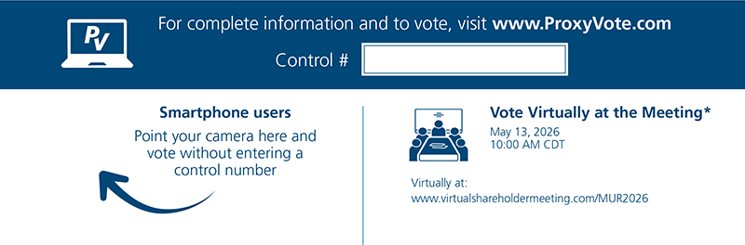

* | Please check the meeting materials for any special requirements for meeting attendance.

Vote at www.ProxyVote.com

THIS IS NOT A VOTABLE BALLOT
This is an overview of the proposals being presented at the
upcoming stockholder meeting. Please follow the instructions on
the reverse side to vote these important matters.

 |  |  |  |  |  |  |  | Board
 |  | Voting Items |  |  |  |  |  | Recommends
 |  |  | 1. |  |  | Election of Directors
 |  |  |  |  |  | Nominees:
 |  |  | 1a. |  |  | C.P. Deming |  | For
 |  |  | 1b. |  |  | L.R. Dickerson |  | For
 |  |  | 1c. |  |  | M.A. Earley |  | For
 |  |  | 1d. |  |  | E.M. Hambly |  | For
 |  |  | 1e. |  |  | E.W. Keller |  | For
 |  |  | 1f. |  |  | R.M. Murphy |  | For
 |  |  | 1g. |  |  | J.W. Nolan |  | For
 |  |  | 1h. |  |  | R.N. Ryan, Jr. |  | For
 |  |  | 1i. |  |  | L.A. Sugg |  | For
 |  |  | 1j. |  |  | R.B. Tudor, III |  | For
 |  |  | 2. |  |  | Advisory vote to approve executive compensation. |  | For
 |  |  | 3. |  |  | Approval of proposed 2026 Stock Plan for Non-Employee Directors. |  | For
 |  |  | 4. |  |  | Approval of the appointment of KPMG LLP as independent registered public accounting firm for 2026. |  | For
NOTE: Such other business as may properly come before the meeting or any adjournment thereof.

Prefer to receive an email instead? While voting on www.ProxyVote.com, be sure to click “Delivery Settings”.
V87595-Z91969-P45252

