UNITED STATES
SECURITIES AND EXCHANGE COMMISSION
WASHINGTON, DC 20549
____________________________

FORM 8-K
____________________________

CURRENT REPORT
Pursuant to Section 13 or 15(d) of the
Securities Exchange Act of 1934

Date of report (Date of earliest event reported): September 8, 2026
____________________________

MURPHY OIL CORPORATION
(Exact Name of Registrant as Specified in Its Charter)
____________________________

Delaware | 1-8590 | 71-0361522
(State or Other Jurisdiction of Incorporation) | (Commission File Number) | (IRS Employer Identification No.)

9805 Katy Fwy, Suite G-200  Houston, Texas | 77024
(Address of Principal Executive Offices) | (Zip Code)

Registrant’s telephone number, including area code: (281) 675-9000

Not applicable
(Former Name or Former Address, if Changed Since Last Report)
____________________________

Check the appropriate box below if the Form 8-K filing is intended to simultaneously satisfy the filing obligation of the registrant under any of the following provisions (see General Instruction A.2. below):

☐ | Written communications pursuant to Rule 425 under the Securities Act (17 CFR 230.425)

☐ | Soliciting material pursuant to Rule 14a-12 under the Exchange Act (17 CFR 240.14a-12)

☐ | Pre-commencement communications pursuant to Rule 14d-2(b) under the Exchange Act (17 CFR 240.14d-2(b))

☐ | Pre-commencement communications pursuant to Rule 13e-4(c) under the Exchange Act (17 CFR 240.13e-4(c))

Securities registered pursuant to Section 12(b) of the Act:

Title of each class | Trading Symbol | Name of each exchange on which registered
Common Stock, $1.00 Par Value | MUR | New York Stock Exchange

Indicate by check mark whether the registrant is an emerging growth company as defined in Rule 405 of the Securities Act of 1933 (§230.405 of this chapter) or Rule 12b-2 of the Securities Exchange Act of 1934 (§240.12b-2 of this chapter). Emerging growth company ☐

If an emerging growth company, indicate by check mark if the registrant has elected not to use the extended transition period for complying with any new or revised financial accounting standards provided pursuant to Section 13(a) of the Exchange Act. ☐

Item 7.01. Regulation FD Disclosure.

On September 9, 2026, Eric M. Hambly, President and Chief Executive Officer of Murphy Oil Corporation (the “Company”), will present at the Barclays 40th Annual Energy-Power Conference and will host investor meetings in connection with the Company’s attendance at the conference. Attached hereto as Exhibit 99.1 is a copy of the presentation prepared by the Company in connection therewith.

The information in this Item 7.01, including Exhibit 99.1, is being furnished and shall not be deemed “filed” for the purposes of Section 18 of the Securities Exchange Act of 1934, as amended (“Exchange Act”), or otherwise subject to the liabilities of that Section, and shall not be incorporated by reference into any registration statement or other document pursuant to the Securities Act of 1933, as amended, or the Exchange Act, except as otherwise expressly stated in such filing.

This Current Report on Form 8-K, including the information furnished pursuant to Item 7.01 and the related Item 9.01 hereto, contains forward-looking statements within the meaning of the Private Securities Litigation Reform Act of 1995. Forward-looking statements are generally identified through the inclusion of words such as “aim”, “anticipate”, “believe”, “drive”, “estimate”, “expect”, “forecast”, “future”, “goal”, “guidance”, “intend”, “may”, “objective”, “outlook”, “plan”, “position”, “potential”, “project”, “seek”, “should”, “strategy”, “target”, “will” or variations of such words and other similar expressions. These statements, which express management’s current views concerning future events, results and plans, are subject to inherent risks, uncertainties and assumptions (many of which are beyond our control) and are not guarantees of performance. In particular, statements, express or implied, concerning the Company’s future operating results or activities and returns or the Company’s ability and intent to replace or increase reserves, increase production, generate returns and rates of return, replace or increase drilling locations, reduce or otherwise control operating costs and expenditures, generate cash flows, pay down or refinance indebtedness, achieve, reach or otherwise meet initiatives, plans, goals, ambitions or targets with respect to emissions, safety matters or other environmental, social and governance matters, make capital expenditures, pay and/or increase dividends or make share repurchases and other capital allocation decisions are forward-looking statements. Factors that could cause one or more of these future events, results or plans not to occur as implied by any forward-looking statement, which consequently could cause actual results or activities to differ materially from the expectations expressed or implied by such forward-looking statements, include, but are not limited to: macro conditions in the oil and natural gas industry, including supply and demand levels, actions taken by major oil exporters and the resulting impacts on commodity prices; geopolitical concerns (including the current conflict in Iran); increased volatility or deterioration in the success rate of our exploration programs or in our ability to maintain production rates and replace reserves; reduced customer demand for our products due to environmental, regulatory, technological or other reasons; adverse foreign exchange movements; political and regulatory instability in the markets where we do business; the impact on our operations or markets of health pandemics and related government responses; natural hazards impacting our operations or markets; any other deterioration in our business, markets or prospects; cyber attacks and other cybersecurity risks; any failure to obtain necessary regulatory approvals; the impact of current and future laws, rulings and governmental regulations; any inability to service or refinance our outstanding debt or to access debt markets at acceptable prices; or adverse developments in the U.S. or global capital markets, credit markets, banking system or economies in general, including inflation, trade policies, tariffs and other trade restrictions. For further discussion of factors that could cause one or more of these future events or results not to occur as implied by any forward-looking statement, see “Risk Factors” in our most recent Annual Report on Form 10-K filed with the U.S. Securities and Exchange Commission (“SEC”) and any subsequent Quarterly Report on Form 10-Q or Current Report on Form 8-K that we file, available from the SEC’s website and from the Company’s website at http://ir.murphyoilcorp.com. Investors and others should note that we may announce material information using SEC filings, press releases, public conference calls, webcasts and the investors page of our website. We may use these channels to distribute material information about the Company; therefore, we encourage investors, the media, business partners and others interested in the Company to review the information we post on our website. The information on our website is not part of, and is not incorporated into, this report. Each forward-looking statement contained in this report speaks only as of the date of this report. Except as required by applicable law, the Company undertakes no duty to publicly update or revise any forward-looking statement, whether as a result of new information, future events or otherwise.

Item 9.01. Financial Statements and Exhibits.

 | (d) | Exhibits
99.1 | Murphy Oil Corporation Presentation dated September 9, 2026.
104 | Cover Page Interactive Data File (embedded within the Inline XBRL document).

SIGNATURES

Pursuant to the requirements of the Securities Exchange Act of 1934, the registrant has duly caused this report to be signed on its behalf by the undersigned hereunto duly authorized.

Date: September 8, 2026 | MURPHY OIL CORPORATION
 | By: | /s/ Paul D. Vaughan
 |  | Name: | Paul D. Vaughan
 |  | Title: | Vice President and Controller


0 0 September 2026 Investor Presentation Barclays 40th Annual Energy - Power Conference 2026 ERIC M. HAMBLY PRESIDENT AND CHIEF EXECUTIVE OFFICER SEPTEMBER 9, 2026

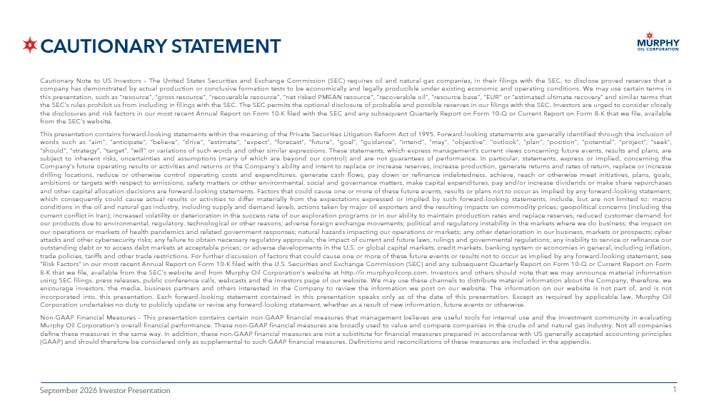
1 1 September 2026 Investor Presentation CAUTIONARY STATEMENT Cautionary Note to US Investors – The United States Securities and Exchange Commission (SEC) requires oil and natural gas companies, in their filings with the SEC, to disclose proved reserves that a company has demonstrated by actual production or conclusive formation tests to be economically and legally producible under existing economic and operating conditions . We may use certain terms in this presentation, such as “resource”, “gross resource”, “recoverable resource”, “net risked PMEAN resource”, “recoverable oil”, “resource base”, “EUR” or “estimated ultimate recovery” and similar terms that the SEC’s rules prohibit us from including in filings with the SEC . The SEC permits the optional disclosure of probable and possible reserves in our filings with the SEC . Investors are urged to consider closely the disclosures and risk factors in our most recent Annual Report on Form 10 - K filed with the SEC and any subsequent Quarterly Report on Form 10 - Q or Current Report on Form 8 - K that we file, available from the SEC’s website . This presentation contains forward - looking statements within the meaning of the Private Securities Litigation Reform Act of 1995 . Forward - looking statements are generally identified through the inclusion of words such as “aim”, “anticipate”, “believe”, “drive”, “estimate”, “expect”, “forecast”, “future”, “goal”, “guidance”, “intend”, “may”, “objective”, “outlook”, “plan”, “position”, “potential”, “project”, “seek”, “should”, “strategy”, “target”, “will” or variations of such words and other similar expressions . These statements, which express management’s current views concerning future events, results and plans, are subject to inherent risks, uncertainties and assumptions (many of which are beyond our control) and are not guarantees of performance . In particular, statements, express or implied, concerning the Company’s future operating results or activities and returns or the Company's ability and intent to replace or increase reserves, increase production, generate returns and rates of return, replace or increase drilling locations, reduce or otherwise control operating costs and expenditures, generate cash flows, pay down or refinance indebtedness, achieve, reach or otherwise meet initiatives, plans, goals, ambitions or targets with respect to emissions, safety matters or other environmental, social and governance matters, make capital expenditures, pay and/or increase dividends or make share repurchases and other capital allocation decisions are forward - looking statements . Factors that could cause one or more of these future events, results or plans not to occur as implied by any forward - looking statement, which consequently could cause actual results or activities to differ materially from the expectations expressed or implied by such forward - looking statements, include, but are not limited to : macro conditions in the oil and natural gas industry, including supply and demand levels, actions taken by major oil exporters and the resulting impacts on commodity prices ; geopolitical concerns (including the current conflict in Iran) ; increased volatility or deterioration in the success rate of our exploration programs or in our ability to maintain production rates and replace reserves ; reduced customer demand for our products due to environmental, regulatory, technological or other reasons ; adverse foreign exchange movements ; political and regulatory instability in the markets where we do business ; the impact on our operations or markets of health pandemics and related government responses ; natural hazards impacting our operations or markets ; any other deterioration in our business, markets or prospects ; cyber attacks and other cybersecurity risks ; any failure to obtain necessary regulatory approvals ; the impact of current and future laws, rulings and governmental regulations ; any inability to service or refinance our outstanding debt or to access debt markets at acceptable prices ; or adverse developments in the U . S . or global capital markets, credit markets, banking system or economies in general, including inflation, trade policies, tariffs and other trade restrictions . For further discussion of factors that could cause one or more of these future events or results not to occur as implied by any forward - looking statement, see “Risk Factors” in our most recent Annual Report on Form 10 - K filed with the U . S . Securities and Exchange Commission (SEC) and any subsequent Quarterly Report on Form 10 - Q or Current Report on Form 8 - K that we file, available from the SEC’s website and from Murphy Oil Corporation’s website at http : //ir . murphyoilcorp . com . Investors and others should note that we may announce material information using SEC filings, press releases, public conference calls, webcasts and the investors page of our website . We may use these channels to distribute material information about the Company ; therefore, we encourage investors, the media, business partners and others interested in the Company to review the information we post on our website . The information on our website is not part of, and is not incorporated into, this presentation . Each forward - looking statement contained in this presentation speaks only as of the date of this presentation . Except as required by applicable law, Murphy Oil Corporation undertakes no duty to publicly update or revise any forward - looking statement, whether as a result of new information, future events or otherwise . Non - GAAP Financial Measures – This presentation contains certain non - GAAP financial measures that management believes are useful tools for internal use and the investment community in evaluating Murphy Oil Corporation’s overall financial performance . These non - GAAP financial measures are broadly used to value and compare companies in the crude oil and natural gas industry . Not all companies define these measures in the same way . In addition, these non - GAAP financial measures are not a substitute for financial measures prepared in accordance with US generally accepted accounting principles (GAAP) and should therefore be considered only as supplemental to such GAAP financial measures . Definitions and reconciliations of these measures are included in the appendix .

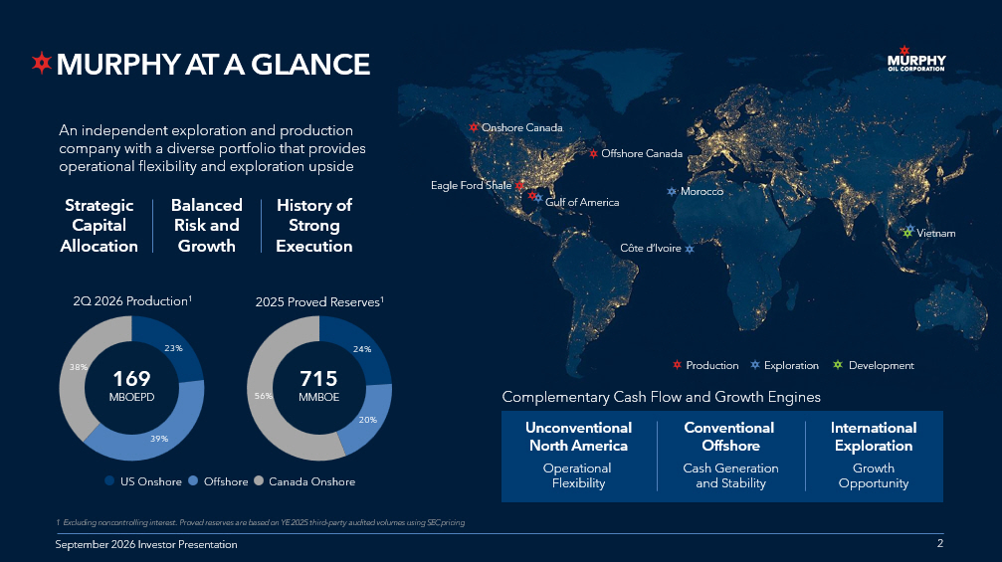
2 2 September 2026 Investor Presentation Eagle Ford Shale Gulf of America Offshore Canada Production Exploration Development Onshore Canada Côte d’Ivoire Vietnam Morocco 2 An independent exploration and production company with a diverse portfolio that provides operational flexibility and exploration upside 1 Excluding noncontrolling interest. Proved reserves are based on YE 2025 third - party audited volumes using SEC pricing Strategic Capital Allocation Balanced Risk and Growth History of Strong Execution US Onshore Offshore Canada Onshore 23% 39% 38% 2Q 2026 Production 1 169 MBOEPD 24% 20% 56% 2025 Proved Reserves 1 715 MMBOE Complementary Cash Flow and Growth Engines Conventional Offshore Cash Generation and Stability Unconventional North America Operational Flexibility International Exploration Growth Opportunity MURPHY AT A GLANCE September 2026 Investor Presentation

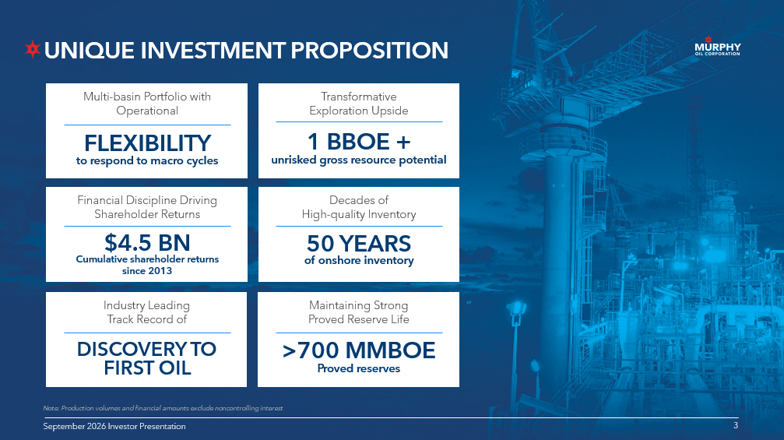
3 3 September 2026 Investor Presentation UNIQUE INVESTMENT PROPOSITION 3 Multi - basin Portfolio with Operational Financial Discipline Driving Shareholder Returns Industry Leading Track Record of Transformative Exploration Upside Decades of High - quality Inventory Maintaining Strong Proved Reserve Life September 2026 Investor Presentation Note: Production volumes and financial amounts exclude noncontrolling interest DISCOVERY TO FIRST OIL >700 MMBOE Proved reserves $4.5 BN Cumulative shareholder returns since 2013 FLEXIBILITY to respond to macro cycles 50 YEARS of onshore inventory 1 BBOE + unrisked gross resource potential

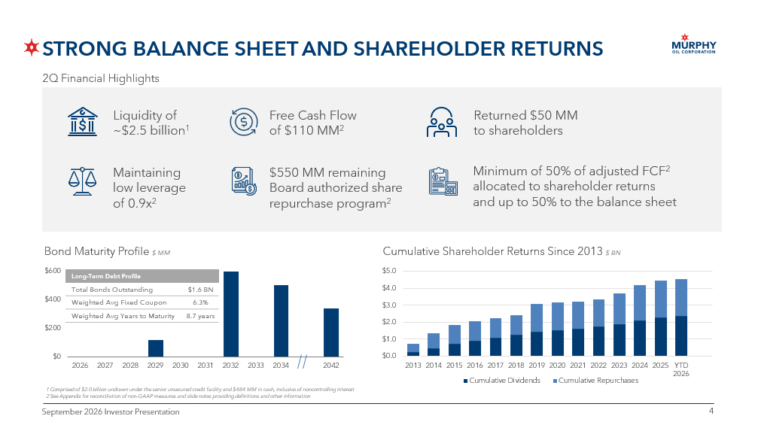
4 4 September 2026 Investor Presentation STRONG BALANCE SHEET AND SHAREHOLDER RETURNS Bond Maturity Profile $ MM $0 $200 $400 $600 2026 2027 2028 2029 2030 2031 2032 2033 2034 2042 Long - Term Debt Profile $1.6 BN Total Bonds Outstanding 6.3% Weighted Avg Fixed Coupon 8.7 years Weighted Avg Years to Maturity 2Q Financial Highlights 1 Comprised of $2.0 billion undrawn under the senior unsecured credit facility and $484 MM in cash, inclusive of noncontrolli ng interest 2 See Appendix for reconciliation of non - GAAP measures and slide notes providing definitions and other information Cumulative Shareholder Returns Since 2013 $ BN $0.0 $1.0 $2.0 $3.0 $4.0 $5.0 2013 2014 2015 2016 2017 2018 2019 2020 2021 2022 2023 2024 2025 YTD 2026 Cumulative Dividends Cumulative Repurchases Liquidity of ~$2.5 billion 1 Maintaining low leverage of 0.9x 2 Free Cash Flow of $110 MM 2 Returned $50 MM to shareholders $550 MM remaining Board authorized share repurchase program 2 Minimum of 50% of adjusted FCF 2 allocated to shareholder returns and up to 50% to the balance sheet

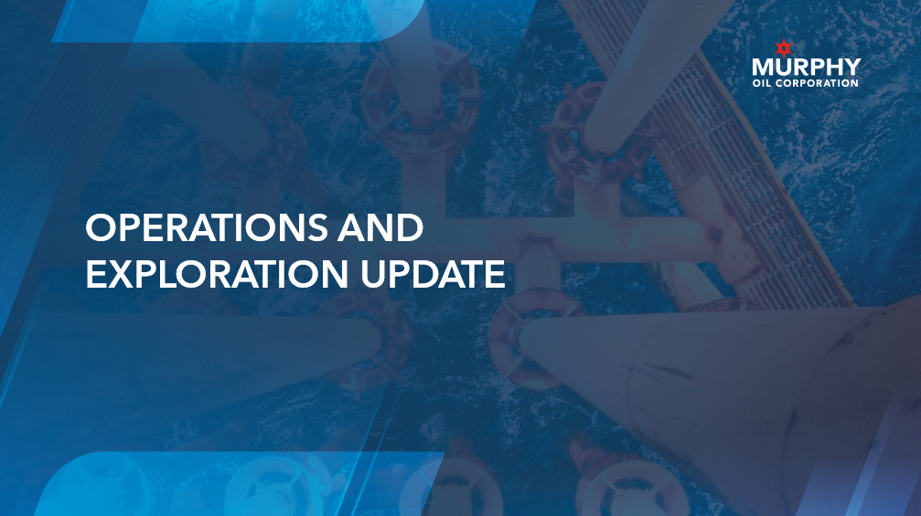
5 5 September 2026 Investor Presentation OPERATIONS AND EXPLORATION UPDATE

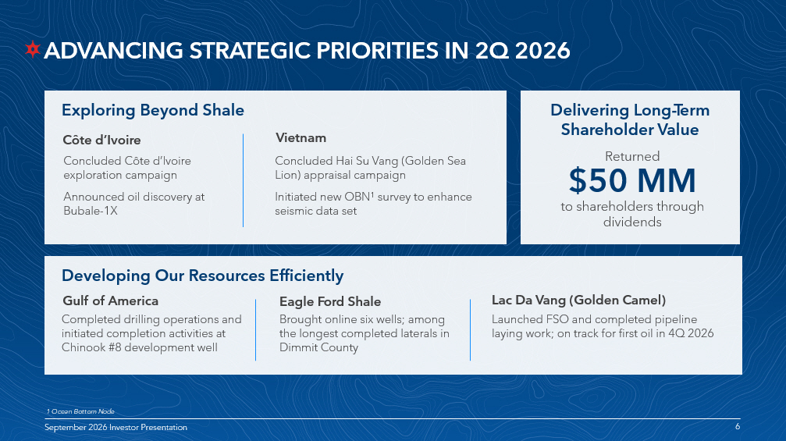
6 6 September 2026 Investor Presentation ADVANCING STRATEGIC PRIORITIES IN 2Q 2026 6 September 2026 Investor Presentation Exploring Beyond Shale Delivering Long - Term Shareholder Value Returned $50 MM to shareholders through dividends Concluded Côte d’Ivoire exploration campaign Announced oil discovery at Bubale - 1X 1 Ocean Bottom Node Concluded Hai Su Vang (Golden Sea Lion) appraisal campaign Initiated new OBN 1 survey to enhance seismic data set Completed drilling operations and initiated completion activities at Chinook #8 development well Developing Our Resources Efficiently Brought online six wells; among the longest completed laterals in Dimmit County Gulf of America Eagle Ford Shale Côte d’Ivoire Vietnam Launched FSO and completed pipeline laying work; on track for first oil in 4Q 2026 Lac Da Vang (Golden Camel)

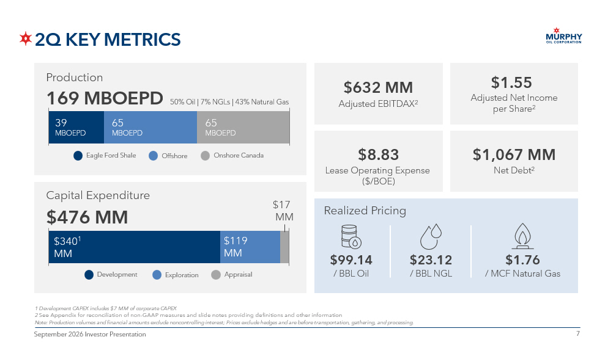
7 7 September 2026 Investor Presentation 2Q KEY METRICS 1 Development CAPEX includes $7 MM of corporate CAPEX 2 See Appendix for reconciliation of non - GAAP measures and slide notes providing definitions and other information Note: Production volumes and financial amounts exclude noncontrolling interest; Prices exclude hedges and are before transportation, gathering, and processing. 39 MBOEPD 65 MBOEPD 65 MBOEPD 50% Oil | 7% NGLs | 43% Natural Gas Eagle Ford Shale Offshore Onshore Canada Production Capital Expenditure Realized Pricing $1,067 MM Net Debt 2 $632 MM Adjusted EBITDAX 2 $1.55 Adjusted Net Income per Share 2 $8.83 Lease Operating Expense ($/BOE) 169 MBOEPD $23.12 / BBL NGL $1.76 / MCF Natural Gas $99.14 / BBL Oil $476 MM $340 1 MM $119 MM $17 MM Development Exploration Appraisal

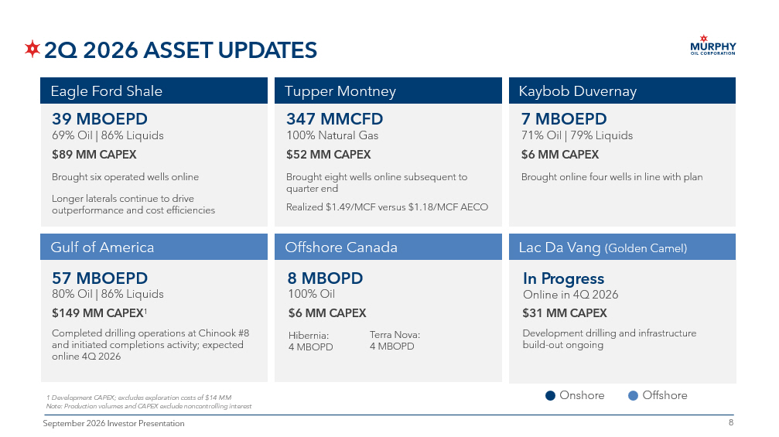
8 8 September 2026 Investor Presentation 2Q 2026 ASSET UPDATES 1 Development CAPEX; excludes exploration costs of $14 MM Note: Production volumes and CAPEX exclude noncontrolling interest Eagle Ford Shale Brought six operated wells online Longer laterals continue to drive outperformance and cost efficiencies 347 MMCFD 100% Natural Gas Brought eight wells online subsequent to quarter end Realized $1.49/MCF versus $1.18/MCF AECO Tupper Montney Tupper Montney Kaybob Duvernay Lac Da Vang (Golden Camel) Offshore Canada Gulf of America 7 MBOEPD 71% Oil | 79% Liquids 57 MBOEPD 80% Oil | 86% Liquids Brought online four wells in line with plan Completed drilling operations at Chinook #8 and initiated completions activity; expected online 4Q 2026 $52 MM CAPEX $6 MM CAPEX 39 MBOEPD 69% Oil | 86% Liquids $89 MM CAPEX $149 MM CAPEX 1 Onshore Offshore 8 MBOPD 100% Oil Hibernia: 4 MBOPD $6 MM CAPEX In Progress Online in 4Q 2026 Development drilling and infrastructure build - out ongoing $31 MM CAPEX Terra Nova: 4 MBOPD

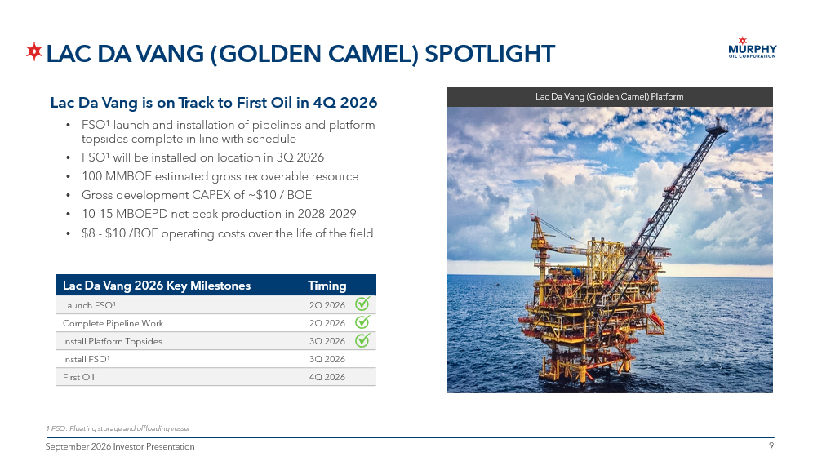
9 9 September 2026 Investor Presentation LAC DA VANG (GOLDEN CAMEL) SPOTLIGHT 1 FSO: Floating storage and offloading vessel Lac Da Vang is on Track to First Oil in 4Q 2026 • FSO 1 launch and installation of pipelines and platform topsides complete in line with schedule • FSO 1 will be installed on location in 3Q 2026 • 100 MMBOE estimated gross recoverable resource • Gross development CAPEX of ~$10 / BOE • 10 - 15 MBOEPD net peak production in 2028 - 2029 • $8 - $10 /BOE operating costs over the life of the field Timing Lac Da Vang 2026 Key Milestones 2Q 2026 Launch FSO 1 2Q 2026 Complete Pipeline Work 3Q 2026 Install Platform Topsides 3Q 2026 Install FSO 1 4Q 2026 First Oil Lac Da Vang (Golden Camel) Platform

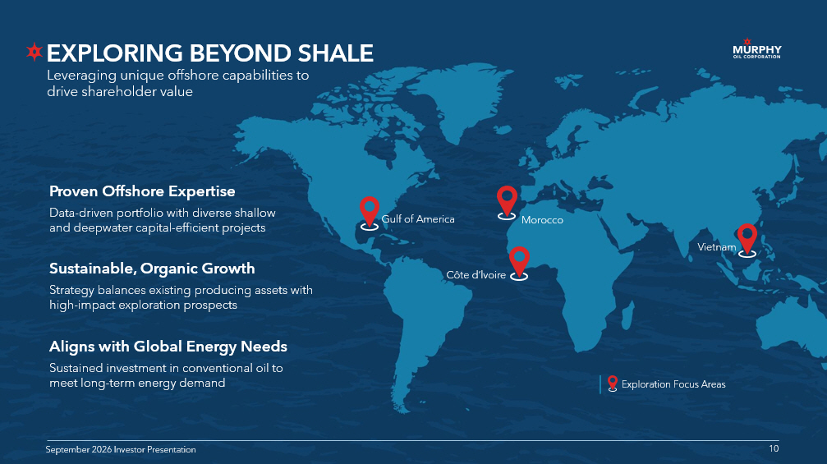
10 10 September 2026 Investor Presentation Proven Offshore Expertise Data - driven portfolio with diverse shallow and deepwater capital - efficient projects Aligns with Global Energy Needs Sustained investment in conventional oil to meet long - term energy demand Sustainable, Organic Growth Strategy balances existing producing assets with high - impact exploration prospects EXPLORING BEYOND SHALE 10 September 2026 Investor Presentation Leveraging unique offshore capabilities to drive shareholder value Gulf of America Côte d’lvoire Vietnam Exploration Focus Areas Morocco

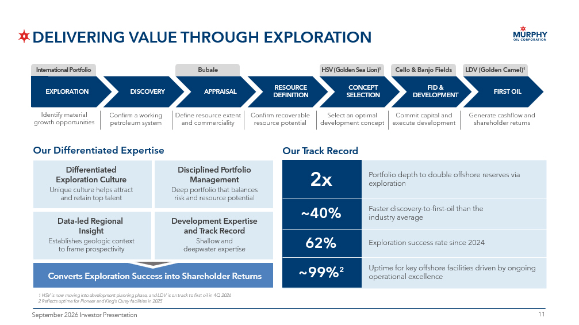
11 11 September 2026 Investor Presentation Our Differentiated Expertise Our Track Record 2x Portfolio depth to double offshore reserves via exploration ~40% Faster discovery - to - first - oil than the industry average ~99% 2 Uptime for key offshore facilities driven by ongoing operational excellence DELIVERING VALUE THROUGH EXPLORATION Confirm a working petroleum system Define resource extent and commerciality Confirm recoverable resource potential Select an optimal development concept Commit capital and execute development Identify material growth opportunities DISCOVERY APPRAISAL RESOURCE DEFINITION CONCEPT SELECTION FID & DEVELOPMENT FIRST OIL Generate cashflow and shareholder returns 62% Exploration success rate since 2024 Differentiated Exploration Culture Unique culture helps attract and retain top talent Data - led Regional Insight Establishes geologic context to frame prospectivity Disciplined Portfolio Management Deep portfolio that balances risk and resource potential Development Expertise and Track Record Shallow and deepwater expertise Converts Exploration Success into Shareholder Returns EXPLORATION International Portfolio Bubale HSV (Golden Sea Lion) 1 Cello & Banjo Fields LDV (Golden Camel) 1 1 HSV is now moving into development planning phase, and LDV is on track to first oil in 4Q 2026 2 Reflects uptime for Pioneer and King’s Quay facilities in 2025

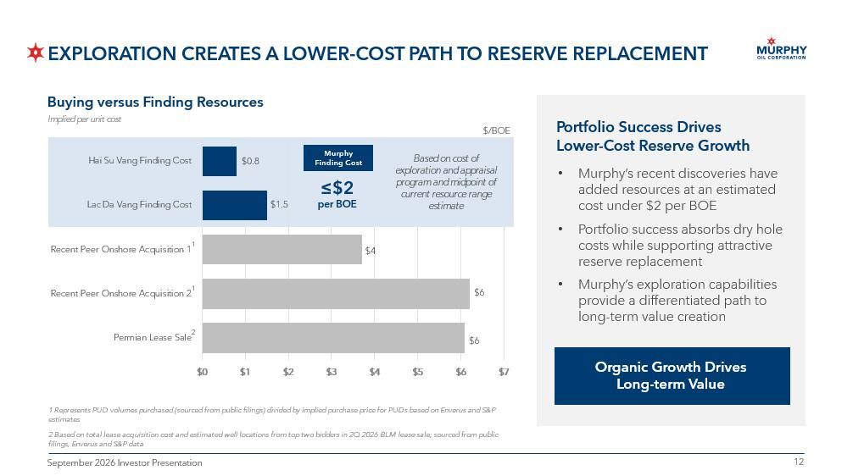
12 12 September 2026 Investor Presentation Implied per unit cost $/BOE 1 Portfolio Success Drives Lower - Cost Reserve Growth Organic Growth Drives Long - term Value Buying versus Finding Resources • Murphy’s recent discoveries have added resources at an estimated cost under $2 per BOE • Portfolio success absorbs dry hole costs while supporting attractive reserve replacement • Murphy’s exploration capabilities provide a differentiated path to long - term value creation 1 Represents PUD volumes purchased (sourced from public filings) divided by implied purchase price for PUDs based on Enverus and S&P estimates 2 Based on total lease acquisition cost and estimated well locations from top two bidders in 2Q 2026 BLM lease sale; sourced fro m public filings , Enverus and S&P data 2 $0 $1 $2 $3 $4 $5 $6 $7 Hai Su Vang Finding Cost Lac Da Vang Finding Cost Bubale Finding Cost Recent Peer Onshore Acquisition 1 Recent Peer Onshore Acquisition 2 Permian Lease Sale Based on estimated cost of exploration and appraisal program and midpoint of current resource range estimate $0.8 Murphy Finding Cost $1.5 $1.8 $4 $6 ≤$2 per BOE $6 1 EXPLORATION CREATES A LOWER - COST PATH TO RESERVE REPLACEMENT

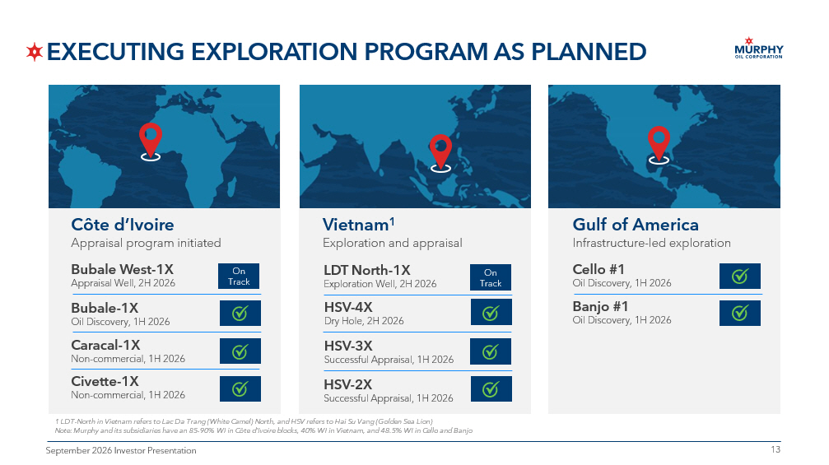
13 13 September 2026 Investor Presentation EXECUTING EXPLORATION PROGRAM AS PLANNED Vietnam 1 Exploration and appraisal LDT North - 1X Exploration Well, 2H 2026 HSV - 4X Dry Hole, 2H 2026 HSV - 3X Successful Appraisal, 1H 2026 Gulf of America Infrastructure - led exploration Banjo #1 Oil Discovery, 1H 2026 Cello #1 Oil Discovery, 1H 2026 Côte d’Ivoire Appraisal program initiated Bubale West - 1X Appraisal Well, 2H 2026 Bubale - 1X Oil Discovery, 1H 2026 Caracal - 1X Non - commercial, 1H 2026 On Track HSV - 2X Successful Appraisal, 1H 2026 Civette - 1X Non - commercial, 1H 2026 On Track 1 LDT - North in Vietnam refers to Lac Da Trang (White Camel) North, and HSV refers to Hai Su Vang (Golden Sea Lion) Note: Murphy and its subsidiaries have an 85 - 90% WI in Côte d’Ivoire blocks, 40% WI in Vietnam, and 48.5% WI in Cello and Banjo

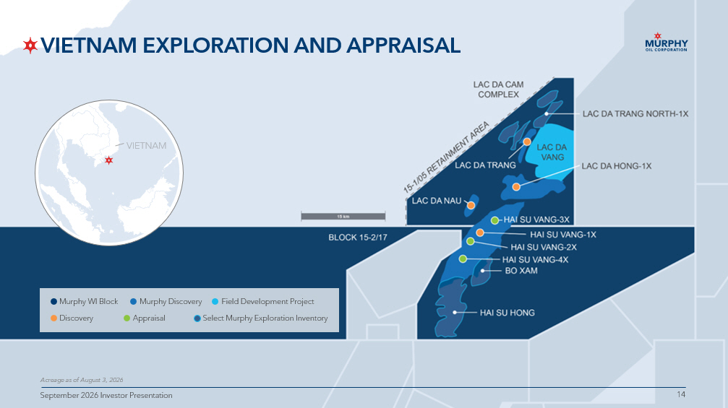
14 14 September 2026 Investor Presentation VIETNAM EXPLORATION AND APPRAISAL Acreage as of August 3 , 2026 Discovery Appraisal Field Development Project Murphy Discovery Murphy WI Block Select Murphy Exploration Inventory 14 September 2026 Investor Presentation

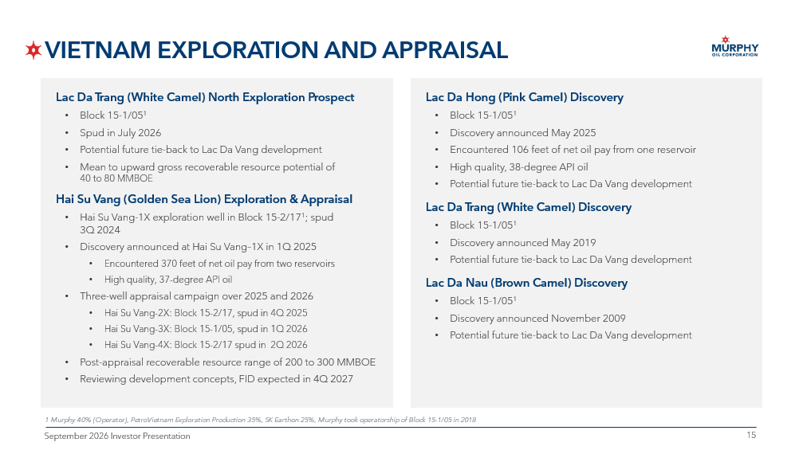
15 15 September 2026 Investor Presentation VIETNAM EXPLORATION AND APPRAISAL 1 Murphy 40% (Operator), PetroVietnam Exploration Production 35%, SK Earthon 25%, Murphy took operatorship of Block 15 - 1/05 in 2018 Lac Da Trang (White Camel) North Exploration Prospect • Block 15 - 1/05 1 • Spud in July 2026 • Potential future tie - back to Lac Da Vang development • Mean to upward gross recoverable resource potential of 40 to 80 MMBOE Hai Su Vang (Golden Sea Lion) Exploration & Appraisal • Hai Su Vang - 1X exploration well in Block 15 - 2/17 1 ; spud 3Q 2024 • Discovery announced at Hai Su Vang – 1X in 1Q 2025 • Encountered 370 feet of net oil pay from two reservoirs • High quality, 37 - degree API oil • Three - well appraisal campaign over 2025 and 2026 • Hai Su Vang - 2X: Block 15 - 2/17, spud in 4Q 2025 • Hai Su Vang - 3X: Block 15 - 1/05, spud in 1Q 2026 • Hai Su Vang - 4X: Block 15 - 2/17 spud in 2Q 2026 • Post - appraisal recoverable resource range of 200 to 300 MMBOE • Reviewing development concepts, FID expected in 4Q 2027 Lac Da Hong (Pink Camel) Discovery • Block 15 - 1/05 1 • Discovery announced May 2025 • Encountered 106 feet of net oil pay from one reservoir • High quality, 38 - degree API oil • Potential future tie - back to Lac Da Vang development Lac Da Trang (White Camel) Discovery • Block 15 - 1/05 1 • Discovery announced May 2019 • Potential future tie - back to Lac Da Vang development Lac Da Nau (Brown Camel) Discovery • Block 15 - 1/05 1 • Discovery announced November 2009 • Potential future tie - back to Lac Da Vang development

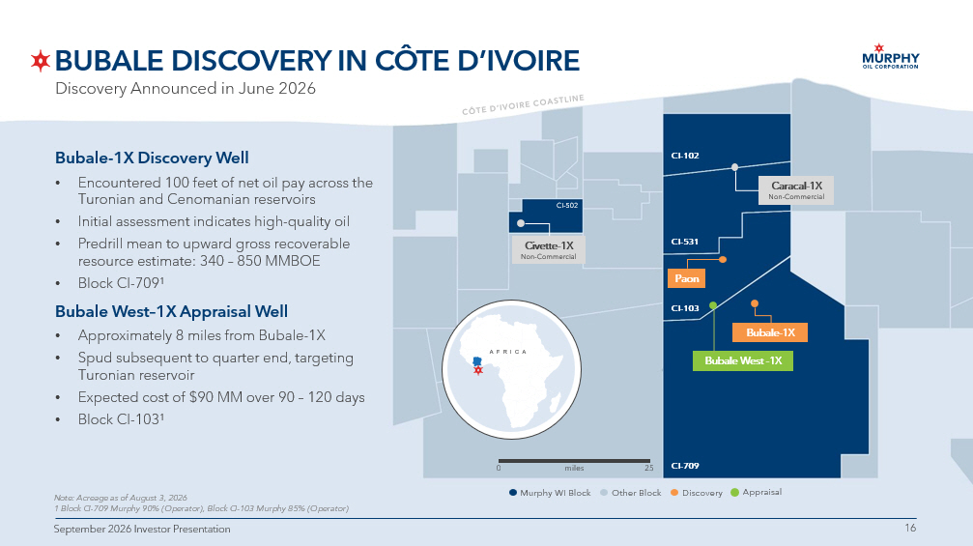
16 16 September 2026 Investor Presentation Gas Processing Facility 40 miles from Bubale - 1X BUBALE DISCOVERY IN CÔTE D’IVOIRE Note: Acreage as of August 3, 2026 1 Block CI - 709 Murphy 90% (Operator), Block CI - 103 Murphy 85% (Operator) Discovery Announced in June 2026 Bubale - 1X Bubale - 1X Discovery Well • Encountered 100 feet of net oil pay across the Turonian and Cenomanian reservoirs • Initial assessment indicates high - quality oil • Predrill mean to upward gross recoverable resource estimate: 340 – 850 MMBOE • Block CI - 709 1 Bubale West – 1X Appraisal Well • Approximately 8 miles from Bubale - 1X • Spud subsequent to quarter end, targeting Turonian reservoir • Expected cost of $90 MM over 90 – 120 days • Block CI - 103 1 16 September 2026 Investor Presentation Paon CI - 502 CI - 102 CI - 531 CI - 103 CI - 709 Civette - 1X Non - Commercial Caracal - 1X Non - Commercial 25 0 miles $)5,& $ Bubale West - 1X Murphy WI Block Other Block Discovery Appraisal

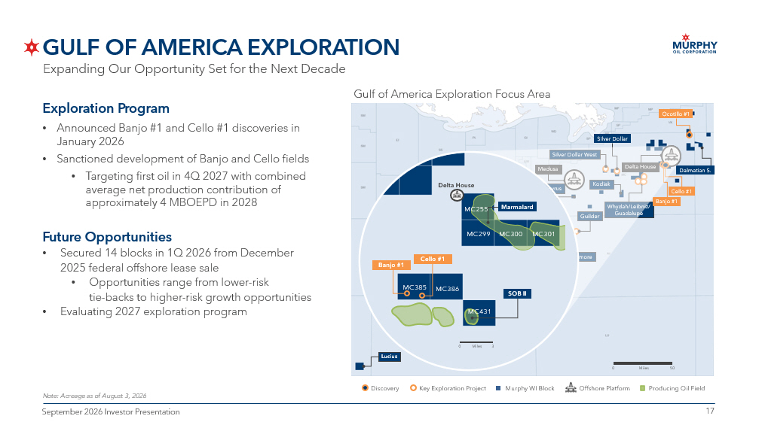
17 17 September 2026 Investor Presentation GULF OF AMERICA EXPLORATION Exploration Program • Announced Banjo #1 and Cello #1 discoveries in January 2026 • Sanctioned development of Banjo and Cello fields • T argeting first oil in 4Q 2027 with combined average net production contribution of approximately 4 MBOEPD in 2028 Future Opportunities • Secured 14 blocks in 1Q 2026 from December 2025 federal offshore lease sale • Opportunities range from lower - risk tie - backs to higher - risk growth opportunities • Evaluating 2027 exploration program Note: Acreage as of August 3, 2026 Gulf of America Exploration Focus Area Miles 50 0 Offshore Platform Murphy WI Block Discovery Key Exploration Project Kodiak Front Runner Medusa Guilder Silver Dollar West Silver Dollar Liberty Longclaw Powerball Ninja Cascade Chinook Lucius St. Malo Whydah/Leibniz/ Guadalupe Delta House Rushmore King’s Quay Ocotillo #1 Dalmatian S. Banjo #1 Zephyrus Cello #1 Miles 3 0 Banjo #1 Cello #1 Delta House MC385 MC386 MC431 Marmalard MC255 MC299 MC300 SOB II MC301 Producing Oil Field Expanding Our Opportunity Set for the Next Decade

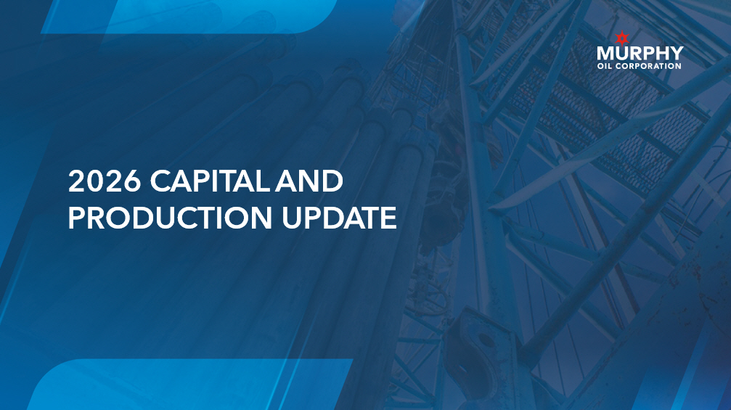
18 18 September 2026 Investor Presentation 2026 CAPITAL AND PRODUCTION UPDATE

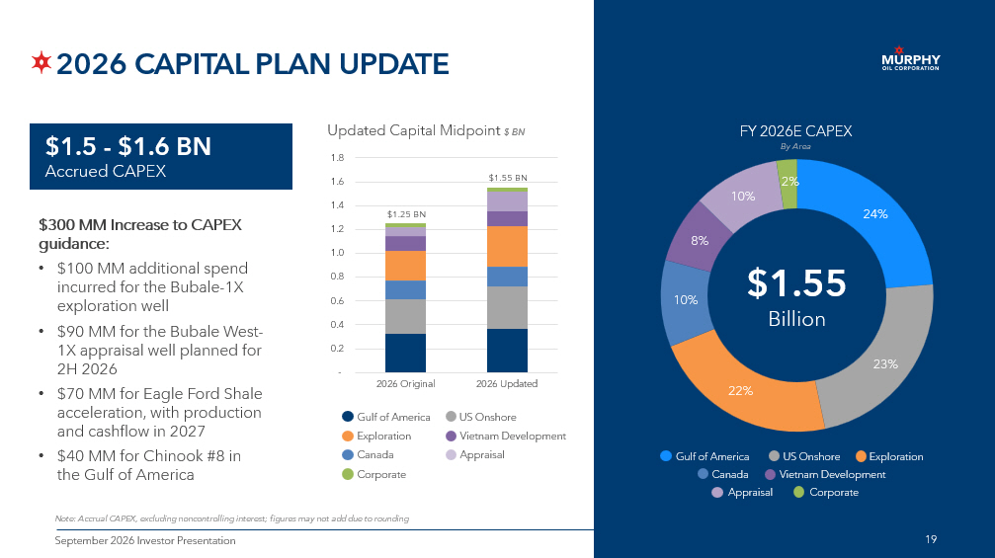
19 19 September 2026 Investor Presentation 2026 CAPITAL PLAN UPDATE Note: Accrual CAPEX, excluding noncontrolling interest; figures may not add due to rounding 24% 23% 22% 10% 8% 10% 2% $1.55 Billion FY 2026E CAPEX By Area $1.5 - $1.6 BN Accrued CAPEX Gulf of America US Onshore Exploration Canada Vietnam Development $300 MM Increase to CAPEX guidance: • $100 MM additional spend incurred for the Bubale - 1X exploration well • $90 MM for the Bubale West - 1X appraisal well planned for 2H 2026 • $70 MM for Eagle Ford Shale acceleration, with production and cashflow in 2027 • $40 MM for Chinook #8 in the Gulf of America 19 - 0.2 0.4 0.6 0.8 1.0 1.2 1.4 1.6 1.8 2026 Original 2026 Updated Updated Capital Midpoint $ BN Gulf of America Canada Exploration Corporate US Onshore Vietnam Development Appraisal Corporate Appraisal $1.25 BN $1.55 BN

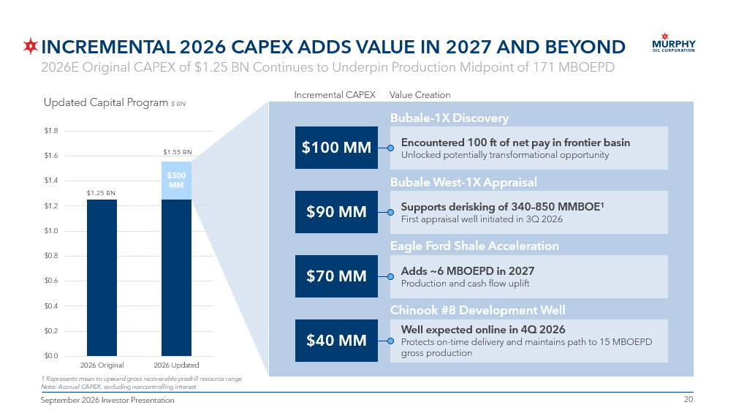
20 20 September 2026 Investor Presentation INCREMENTAL 2026 CAPEX ADDS VALUE IN 2027 AND BEYOND 1 R epresents mean to upward gross recoverable predrill resource range Note: Accrual CAPEX, excluding noncontrolling interest $0.0 $0.2 $0.4 $0.6 $0.8 $1.0 $1.2 $1.4 $1.6 $1.8 2026 Original 2026 Updated Updated Capital Program $ BN $1.25 BN $1.55 BN $300 MM Value Creation Incremental CAPEX Bubale - 1X Discovery $100 MM Encountered 100 ft of net pay in frontier basin Unlocked potentially transformational opportunity Bubale West - 1X Appraisal $90 MM Supports de risking of 340 – 850 MMBOE 1 First appraisal well initiated in 3Q 2026 Eagle Ford Shale Acceleration $70 MM Adds ~6 MBOEPD in 2027 Production and cash flow uplift Chinook #8 Development Well $40 MM Well expected online in 4Q 2026 Protects on - time delivery and maintains path to 15 MBOEPD gross production 2026E Original CAPEX of $1.25 BN Continues to Underpin Production Midpoint of 171 MBOEPD

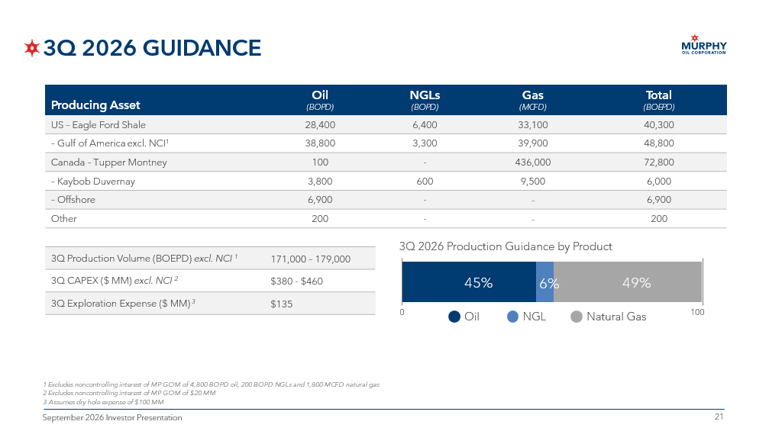
21 21 September 2026 Investor Presentation 3Q 2026 GUIDANCE Total (BOEPD) Gas (MCFD) NGLs (BOPD) Oil (BOPD) Producing Asset 40,300 33,100 6,400 28,400 US – Eagle Ford Shale 48,800 39,900 3,300 38,800 – Gulf of America excl. NCI 1 72,800 436,000 - 100 Canada – Tupper Montney 6,000 9,500 600 3,800 – Kaybob Duvernay 6,900 - - 6,900 – Offshore 200 - - 200 Other 171,000 – 179,000 3Q Production Volume (BOEPD) excl. NCI 1 $380 - $460 3Q CAPEX ($ MM) excl. NCI 2 $135 3Q Exploration Expense ($ MM) 3 1 Excludes noncontrolling interest of MP GOM of 4,800 BOPD oil, 200 BOPD NGLs and 1,800 MCFD natural gas 2 Excludes noncontrolling interest of MP GOM of $20 MM 3 Assumes dry hole expense of $100 MM 3Q 2026 Production Guidance by Product 45% 6% 49% Oil NGL Natural Gas 0 100

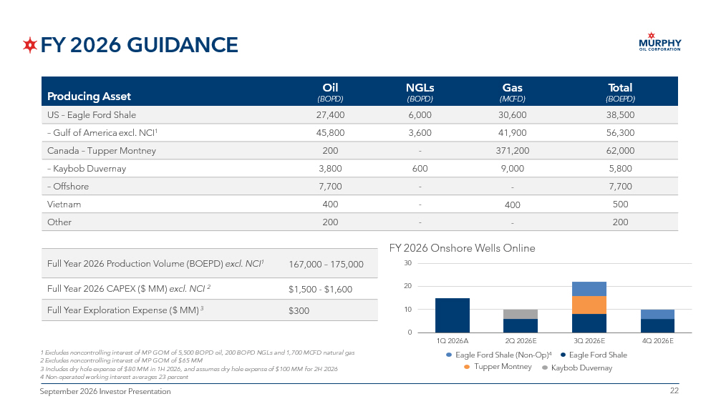
22 22 September 2026 Investor Presentation FY 2026 GUIDANCE Total (BOEPD) Gas (MCFD) NGLs (BOPD) Oil (BOPD) Producing Asset 38,500 30,600 6,000 27,400 US – Eagle Ford Shale 56,300 41,900 3,600 45,800 – Gulf of America excl. NCI 1 62,000 371,200 - 200 Canada – Tupper Montney 5,800 9,000 600 3,800 – Kaybob Duvernay 7,700 - - 7,700 – Offshore 500 400 - 400 Vietnam 200 - - 200 Other 167,000 – 175,000 Full Year 2026 Production Volume (BOEPD) excl. NCI 1 $1,500 - $1,600 Full Year 2026 CAPEX ($ MM) excl. NCI 2 $300 Full Year Exploration Expense ($ MM) 3 1 Excludes noncontrolling interest of MP GOM of 5,500 BOPD oil, 200 BOPD NGLs and 1,700 MCFD natural gas 2 Excludes noncontrolling interest of MP GOM of $65 MM 3 Includes dry hole expense of $80 MM in 1H 2026, and assumes dry hole expense of $100 MM for 2H 2026 4 Non - operated working interest averages 23 percent FY 2026 Onshore Wells Online 0 10 20 30 1Q 2026A 2Q 2026E 3Q 2026E 4Q 2026E Eagle Ford Shale (Non - Op) 4 Eagle Ford Shale Tupper Montney Kaybob Duvernay

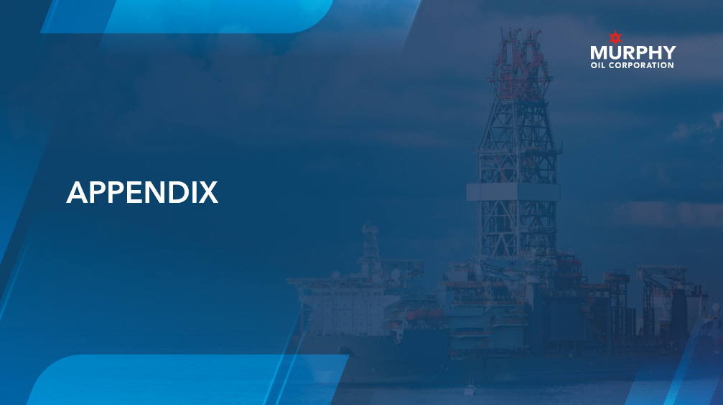
23 23 September 2026 Investor Presentation APPENDIX

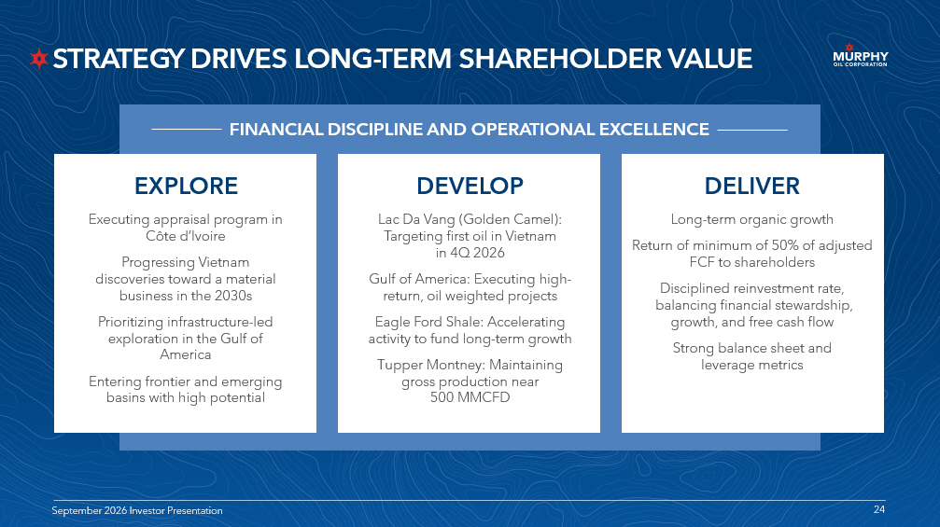
24 24 September 2026 Investor Presentation STRATEGY DRIVES LONG - TERM SHAREHOLDER VALUE EXPLORE DEVELOP DELIVER 24 September 2026 Investor Presentation Lac Da Vang (Golden Camel): Targeting first oil in Vietnam in 4Q 2026 Gulf of America: Executing high - return, oil weighted projects Eagle Ford Shale: Accelerating activity to fund long - term growth Tupper Montney: Maintaining gross production near 500 MMCFD Long - term organic growth Return of minimum of 50% of adjusted FCF to shareholders Disciplined reinvestment rate, balancing financial stewardship, growth, and free cash flow Strong balance sheet and leverage metrics FINANCIAL DISCIPLINE AND OPERATIONAL EXCELLENCE Executing appraisal program in Côte d’Ivoire Progressing Vietnam discoveries toward a material business in the 2030s Prioritizing infrastructure - led exploration in the Gulf of America Entering frontier and emerging basins with high potential

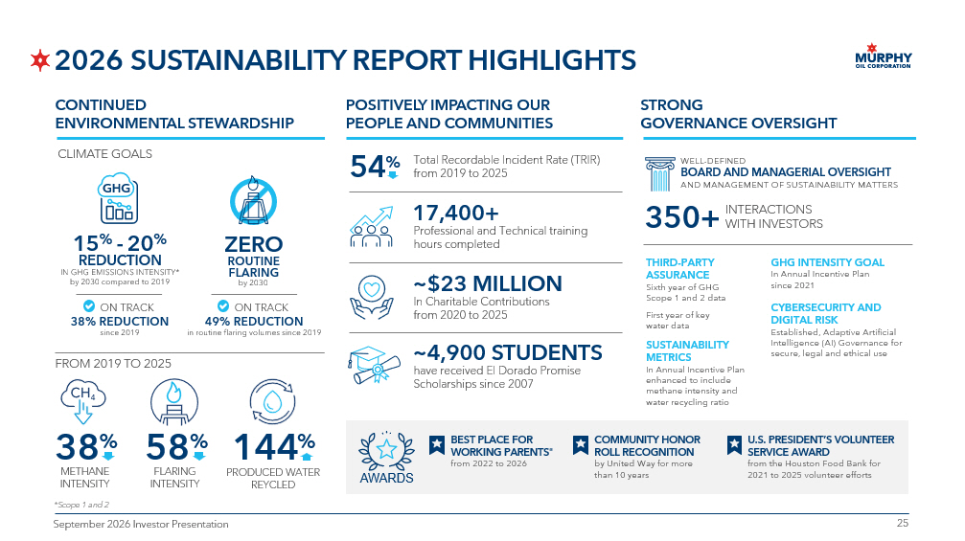
25 25 September 2026 Investor Presentation 2026 SUSTAINABILITY REPORT HIGHLIGHTS CONTINUED ENVIRONMENTAL STEWARDSHIP STRONG GOVERNANCE OVERSIGHT POSITIVELY IMPACTING OUR PEOPLE AND COMMUNITIES have received El Dorado Promise Scholarships since 2007 ~4,900 STUDENTS In Charitable Contributions from 2020 to 2025 ~$23 MILLION Professional and Technical training hours completed 17,400+ Total Recordable Incident Rate (TRIR) from 2019 to 2025 FROM 2019 TO 2025 15 % - 20 % REDUCTION IN GHG EMISSIONS INTENSITY* by 2030 compared to 2019 38% REDUCTION since 2019 ON TRACK ZERO ROUTINE FLARING by 2030 49% REDUCTION in routine flaring volumes since 2019 ON TRACK THIRD - PARTY ASSURANCE Sixth year of GHG Scope 1 and 2 data First year of key water data SUSTAINABILITY METRICS In Annual Incentive Plan enhanced to include methane intensity and water recycling ratio CYBERSECURITY AND DIGITAL RISK Established, Adaptive Artificial Intelligence (AI) Governance for secure, legal and ethical use GHG INTENSITY GOAL In Annual Incentive Plan since 2021 WELL - DEFINED BOARD AND MANAGERIAL OVERSIGHT AND MANAGEMENT OF SUSTAINABILITY MATTERS INTERACTIONS WITH INVESTORS 350+ BEST PLACE FOR WORKING PARENTS ® from 2022 to 2026 U.S. PRESIDENT’S VOLUNTEER SERVICE AWARD from the Houston Food Bank for 2021 to 2025 volunteer efforts COMMUNITY HONOR ROLL RECOGNITION by United Way for more than 10 years CLIMATE GOALS 38 % METHANE INTENSITY 58 % FLARING INTENSITY 144 % PRODUCED WATER REYCLED *Scope 1 and 2 $:$5'6 GHG 54 %

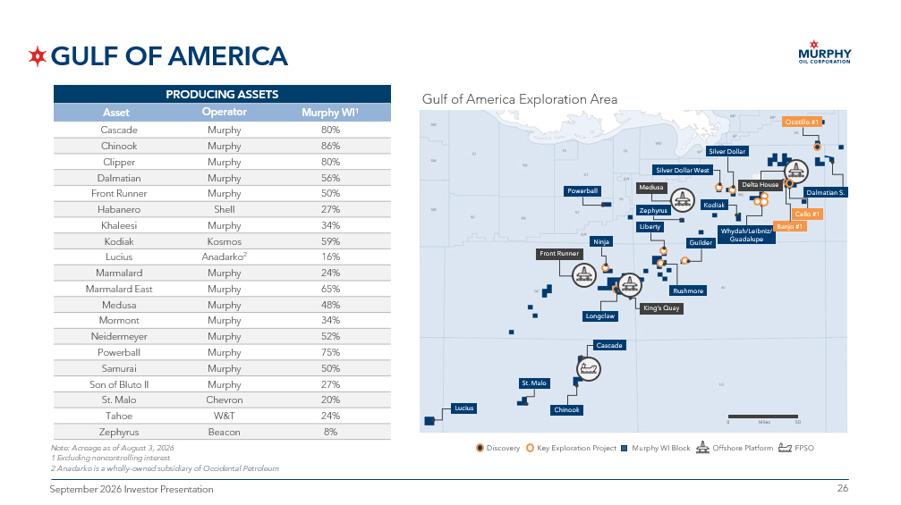
26 26 September 2026 Investor Presentation GULF OF AMERICA Note: Acreage as of August 3 , 2026 1 Excluding noncontrolling interest 2 Anadarko is a wholly - owned subsidiary of Occidental Petroleum PRODUCING ASSETS Murphy WI 1 Operator Asset 80% Murphy Cascade 86% Murphy Chinook 80% Murphy Clipper 56% Murphy Dalmatian 50% Murphy Front Runner 27% Shell Habanero 34% Murphy Khaleesi 59% Kosmos Kodiak 16% Anadarko 2 Lucius 24% Murphy Marmalard 65% Murphy Marmalard East 48% Murphy Medusa 34% Murphy Mormont 52% Murphy Neidermeyer 75% Murphy Powerball 50% Murphy Samurai 27% Murphy Son of Bluto II 20% Chevron St. Malo 24% W&T Tahoe 8% Beacon Zephyrus Gulf of America Exploration Area Offshore Platform FPSO Murphy WI Block Discovery Key Exploration Project Miles 50 0 Kodiak Front Runner Medusa Guilder Silver Dollar West Silver Dollar Liberty Longclaw Powerball Ninja Cascade Chinook Lucius St. Malo Whydah/Leibniz/ Guadalupe Delta House Rushmore King’s Quay Ocotillo #1 Dalmatian S. Zephyrus Banjo #1 Cello #1

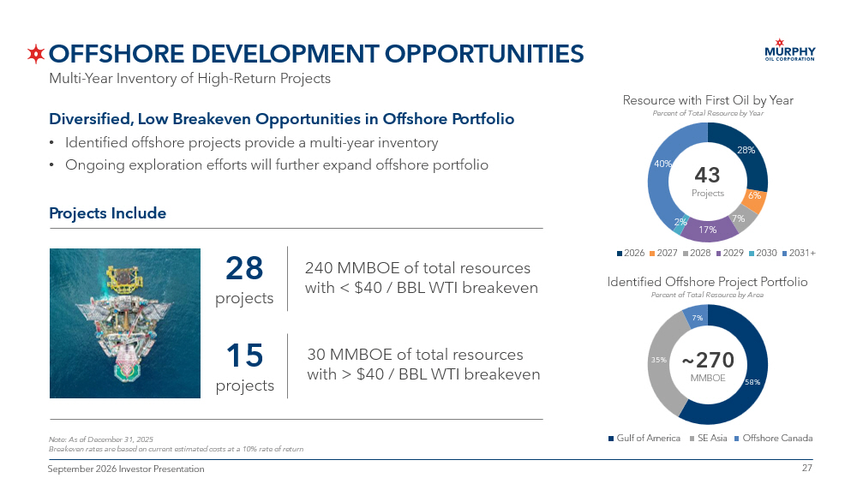
27 27 September 2026 Investor Presentation OFFSHORE DEVELOPMENT OPPORTUNITIES Multi - Year Inventory of High - Return Projects Diversified, Low Breakeven Opportunities in Offshore Portfolio • Identified offshore projects provide a multi - year inventory • Ongoing exploration efforts will further expand offshore portfolio Identified Offshore Project Portfolio Percent of Total Resource by Area Note: As of December 31, 2025 Breakeven rates are based on current estimated costs at a 10% rate of return Gulf of America Offshore Canada SE Asia Resource with First Oil by Year Percent of Total Resource by Year Projects Include 28 projects 15 projects 240 MMBOE of total resources with < $ 40 / BBL WTI breakeven 30 MMBOE of total resources with > $ 40 / BBL WTI breakeven 58% 35% 7% 28% 6% 7% 17% 2% 40% 2026 2027 2028 2029 2030 2031+ ~270 MMBOE 43 Projects

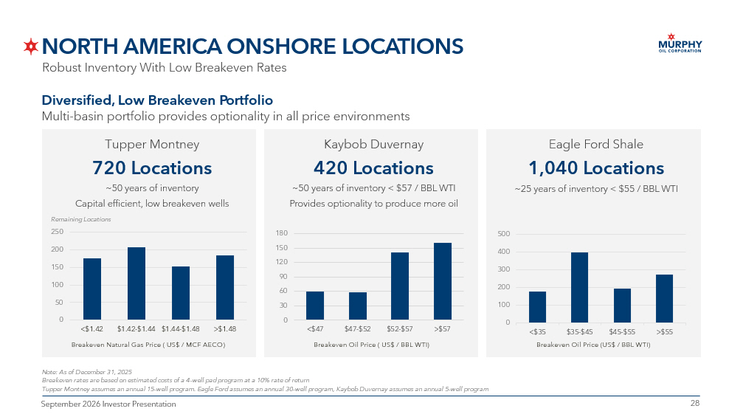
28 28 September 2026 Investor Presentation Kaybob Duvernay 420 Locations ~50 years of inventory < $57 / BBL WTI Provides optionality to produce more oil NORTH AMERICA ONSHORE LOCATIONS Robust Inventory With Low Breakeven Rates Diversified, Low Breakeven Portfolio Multi - basin portfolio provides optionality in all price environments Tupper Montney 720 Locations ~50 years of inventory Capital efficient, low breakeven wells Note: As of December 31, 2025 Breakeven rates are based on estimated costs of a 4 - well pad program at a 10% rate of return Tupper Montney assumes an annual 15 - well program. Eagle Ford assumes an annual 30 - well program, Kaybob Duvernay assumes an annual 5 - well program Eagle Ford Shale 1,040 Locations ~ 25 years of inventory < $55 / BBL WTI 0 100 200 300 400 500 <$35 $35-$45 $45-$55 >$55 0 50 100 150 200 250 <$1.42 $1.42-$1.44 $1.44-$1.48 >$1.48 Breakeven Natural Gas Price ( US$ / MCF AECO) Breakeven Oil Price ( US$ / BBL WTI) Breakeven Oil Price (US$ / BBL WTI) Remaining Locations 0 30 60 90 120 150 180 <$47 $47-$52 $52-$57 >$57

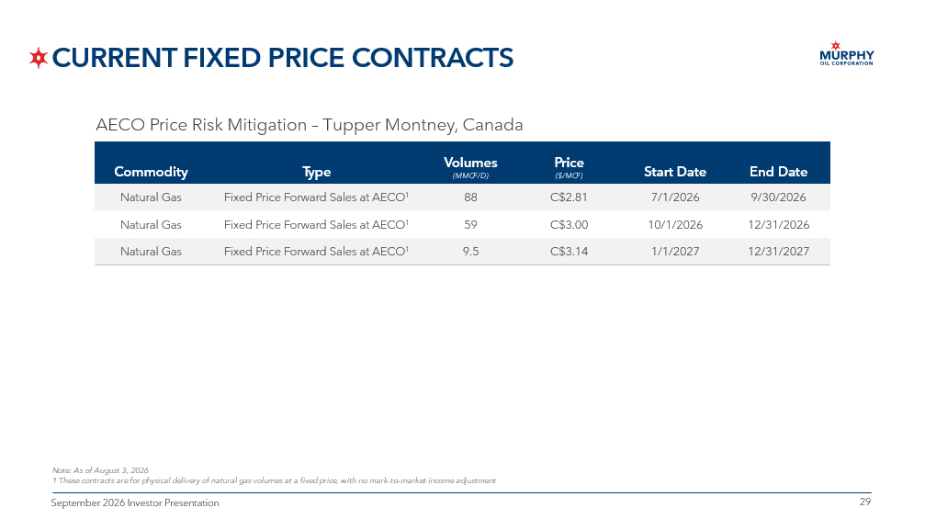
29 29 September 2026 Investor Presentation CURRENT FIXED PRICE CONTRACTS End Date Start Date Price ($/MCF) Volumes (MMCF/D) Type Commodity 9/30/2026 7/1/2026 C$2.81 88 Fixed Price Forward Sales at AECO 1 Natural Gas 12/31/2026 10/1/2026 C$3.00 59 Fixed Price Forward Sales at AECO 1 Natural Gas 12/31/2027 1/1/2027 C$3.14 9.5 Fixed Price Forward Sales at AECO 1 Natural Gas Note: As of August 3, 2026 1 These contracts are for physical delivery of natural gas volumes at a fixed price, with no mark - to - market income adjustment AECO Price Risk Mitigation – Tupper Montney, Canada

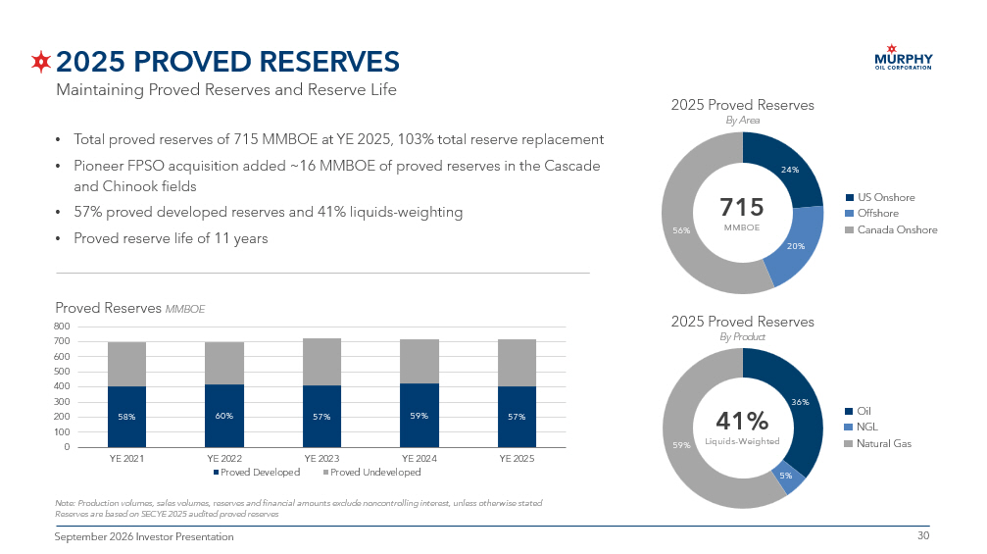
30 30 September 2026 Investor Presentation 2025 PROVED RESERVES 24% 20% 56% • Total proved reserves of 715 MMBOE at YE 2025, 103% total reserve replacement • Pioneer FPSO acquisition added ~16 MMBOE of proved reserves in the Cascade and Chinook fields • 57% proved developed reserves and 41% liquids - weighting • Proved reserve life of 11 years Note: Production volumes, sales volumes, reserves and financial amounts exclude noncontrolling interest, unless otherwise sta ted Reserves are based on SEC YE 2025 audited proved reserves 715 MMBOE 2025 Proved Reserves By Area US Onshore Offshore Canada Onshore 58% 60% 57% 59% 57% 0 100 200 300 400 500 600 700 800 YE 2021 YE 2022 YE 2023 YE 2024 YE 2025 Proved Developed Proved Undeveloped Proved Reserves MMBOE 36% 5% 59% 41 % Liquids - Weighted 2025 Proved Reserves By Product Oil NGL Natural Gas Maintaining Proved Reserves and Reserve Life

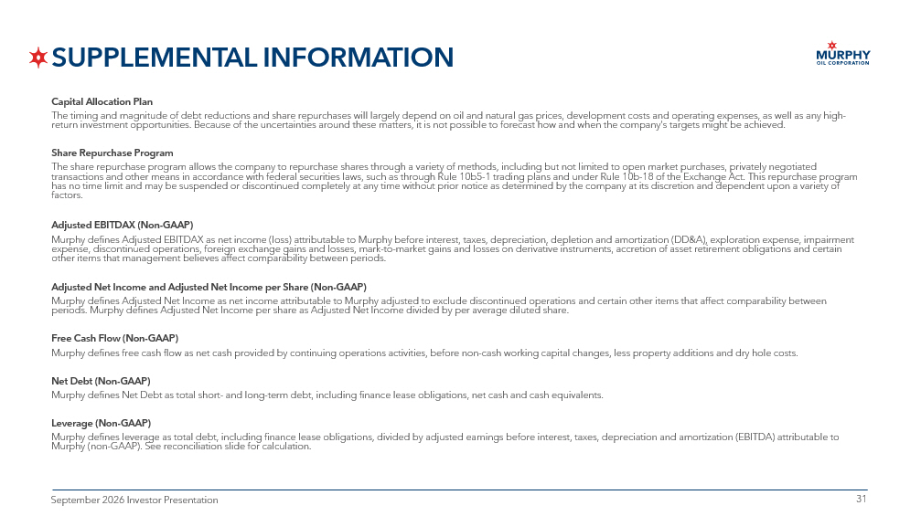
31 31 September 2026 Investor Presentation SUPPLEMENTAL INFORMATION Capital Allocation Plan The timing and magnitude of debt reductions and share repurchases will largely depend on oil and natural gas prices, developm ent costs and operating expenses, as well as any high - return investment opportunities. Because of the uncertainties around these matters, it is not possible to forecast how and wh en the company’s targets might be achieved. Share Repurchase Program The share repurchase program allows the company to repurchase shares through a variety of methods, including but not limited to open market purchases, privately negotiated transactions and other means in accordance with federal securities laws, such as through Rule 10b5 - 1 trading plans and under Rul e 10b - 18 of the Exchange Act. This repurchase program has no time limit and may be suspended or discontinued completely at any time without prior notice as determined by the compa ny at its discretion and dependent upon a variety of factors. Adjusted EBITDAX (Non - GAAP) Murphy defines Adjusted EBITDAX as net income (loss) attributable to Murphy before interest, taxes, depreciation, depletion a nd amortization (DD&A), exploration expense, impairment expense, discontinued operations, foreign exchange gains and losses, mark - to - market gains and losses on derivative instruments, accretion of asset retirement obligations and certain other items that management believes affect comparability between periods. Adjusted Net Income and Adjusted Net Income per Share (Non - GAAP) Murphy defines Adjusted Net Income as net income attributable to Murphy adjusted to exclude discontinued operations and certa in other items that affect comparability between periods. Murphy defines Adjusted Net Income per share as Adjusted Net Income divided by per average diluted share. Free Cash Flow (Non - GAAP) Murphy defines free cash flow as net cash provided by continuing operations activities, before non - cash working capital changes, less property additions and dry hole costs. Net Debt (Non - GAAP) Murphy defines Net Debt as total short - and long - term debt, including finance lease obligations, net cash and cash equivalents. Leverage (Non - GAAP) Murphy defines leverage as total debt, including finance lease obligations, divided by adjusted earnings before interest, tax es, depreciation and amortization (EBITDA) attributable to Murphy (non - GAAP). See reconciliation slide for calculation.

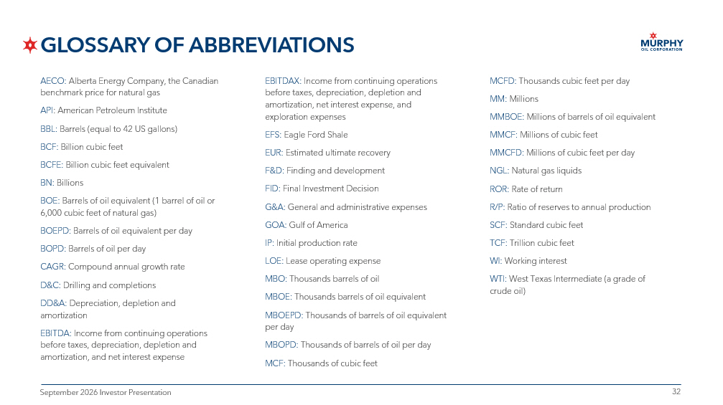
32 32 September 2026 Investor Presentation GLOSSARY OF ABBREVIATIONS AECO: Alberta Energy Company, the Canadian benchmark price for natural gas API : American Petroleum Institute BBL: Barrels (equal to 42 US gallons) BCF: Billion cubic feet BCFE: Billion cubic feet equivalent BN: Billions BOE: Barrels of oil equivalent (1 barrel of oil or 6,000 cubic feet of natural gas) BOEPD: Barrels of oil equivalent per day BOPD: Barrels of oil per day CAGR: Compound annual growth rate D&C: Drilling and completions DD&A: Depreciation, depletion and amortization EBITDA: Income from continuing operations before taxes, depreciation, depletion and amortization, and net interest expense EBITDAX: Income from continuing operations before taxes, depreciation, depletion and amortization, net interest expense, and exploration expenses EFS: Eagle Ford Shale EUR: Estimated ultimate recovery F&D: Finding and development FID: Final Investment Decision G&A: General and administrative expenses GOA: Gulf of America IP: Initial production rate LOE: Lease operating expense MBO: Thousands barrels of oil MBOE: Thousands barrels of oil equivalent MBOEPD: Thousands of barrels of oil equivalent per day MBOPD: Thousands of barrels of oil per day MCF: Thousands of cubic feet MCFD: Thousands cubic feet per day MM: Millions MMBOE: Millions of barrels of oil equivalent MMCF: Millions of cubic feet MMCFD: Millions of cubic feet per day NGL: Natural gas liquids ROR: Rate of return R/P: Ratio of reserves to annual production SCF: Standard cubic feet TCF: Trillion cubic feet WI: Working interest WTI: West Texas Intermediate (a grade of crude oil)

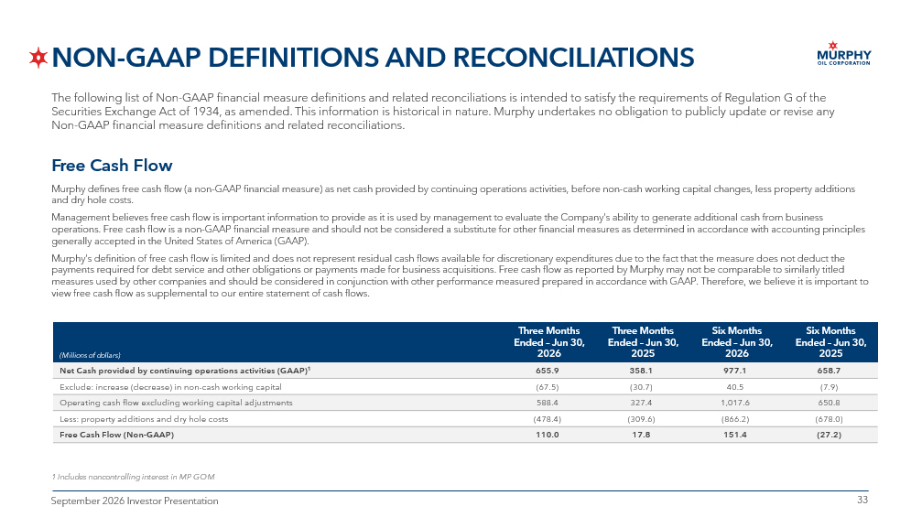
33 33 September 2026 Investor Presentation NON - GAAP DEFINITIONS AND RECONCILIATIONS Six Months Ended – Jun 30, 2025 Six Months Ended – Jun 30, 2026 Three Months Ended – Jun 30, 2025 Three Months Ended – Jun 30, 2026 (Millions of dollars) 658.7 977.1 358.1 655.9 Net Cash provided by continuing operations activities (GAAP) 1 (7.9) 40.5 (30.7) (67.5) Exclude: increase (decrease) in non - cash working capital 650.8 1,017.6 327.4 588.4 Operating cash flow excluding working capital adjustments (678.0) (866.2) (309.6) (478.4) Less: property additions and dry hole costs (27.2) 151.4 17.8 110.0 Free Cash Flow (Non - GAAP) Free Cash Flow Murphy defines free cash flow (a non - GAAP financial measure) as net cash provided by continuing operations activities, before no n - cash working capital changes, less property additions and dry hole costs. Management believes free cash flow is important information to provide as it is used by management to evaluate the Company’s abi lity to generate additional cash from business operations. F ree cash flow is a non - GAAP financial measure and should not be considered a substitute for other financial measures as determined in accordance with accounting principles generally accepted in the United States of America (GAAP). Murphy’s definition of free cash flow is limited and does not represent residual cash flows available for discretionary expen dit ures due to the fact that the measure does not deduct the payments required for debt service and other obligations or payments made for business acquisitions. Free cash flow as report ed by Murphy may not be comparable to similarly titled measures used by other companies and should be considered in conjunction with other performance measured prepared in accordan ce with GAAP. Therefore, we believe it is important to view fre e cash flow as supplemental to our entire statement of cash flows. The following list of Non - GAAP financial measure definitions and related reconciliations is intended to satisfy the requirements of Regulation G of the Securities Exchange Act of 1934, as amended. This information is historical in nature. Murphy undertakes no obligation to pub lic ly update or revise any Non - GAAP financial measure definitions and related reconciliations. 1 Includes noncontrolling interest in MP GOM

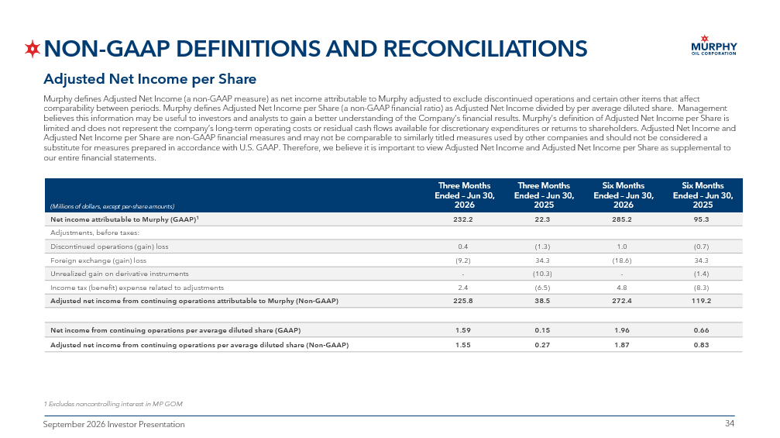
34 34 September 2026 Investor Presentation NON - GAAP DEFINITIONS AND RECONCILIATIONS Adjusted Net Income per Share Murphy defines Adjusted Net Income (a non - GAAP measure) as net income attributable to Murphy adjusted to exclude discontinued op erations and certain other items that affect comparability between periods. Murphy defines Adjusted Net Income per Share (a non - GAAP financial ratio) as Adjusted Net Income divided by per average diluted share. Management believes this information may be useful to investors and analysts to gain a better understanding of the Company’s financial r esu lts. Murphy’s definition of Adjusted Net Income per Share is limited and does not represent the company’s long - term operating costs or residual cash flows available for discretionary expend itures or returns to shareholders. Adjusted Net Income and Adjusted Net Income per Share are non - GAAP financial measures and may not be comparable to similarly titled measures used by oth er companies and should not be considered a substitute for measures prepared in accordance with U.S. GAAP. Therefore, we believe it is important to view Adjusted Net Inc ome and Adjusted Net Income per Share as supplemental to our entire financial statements. 1 Excludes noncontrolling interest in MP GOM Six Months Ended – Jun 30, 2025 Six Months Ended – Jun 30, 2026 Three Months Ended – Jun 30, 2025 Three Months Ended – Jun 30, 2026 (Millions of dollars, except per - share amounts) 95.3 285.2 22.3 232.2 Net income attributable to Murphy (GAAP) 1 Adjustments, before taxes: (0.7) 1.0 (1.3) 0.4 Discontinued operations (gain) loss 34.3 (18.6) 34.3 (9.2) Foreign exchange (gain) loss (1.4) - (10.3) - Unrealized gain on derivative instruments (8.3) 4.8 (6.5) 2.4 Income tax (benefit) expense related to adjustments 119.2 272.4 38.5 225.8 Adjusted net income from continuing operations attributable to Murphy (Non - GAAP) 0.66 1.96 0.15 1.59 Net income from continuing operations per average diluted share (GAAP) 0.83 1.87 0.27 1.55 Adjusted net income from continuing operations per average diluted share (Non - GAAP)

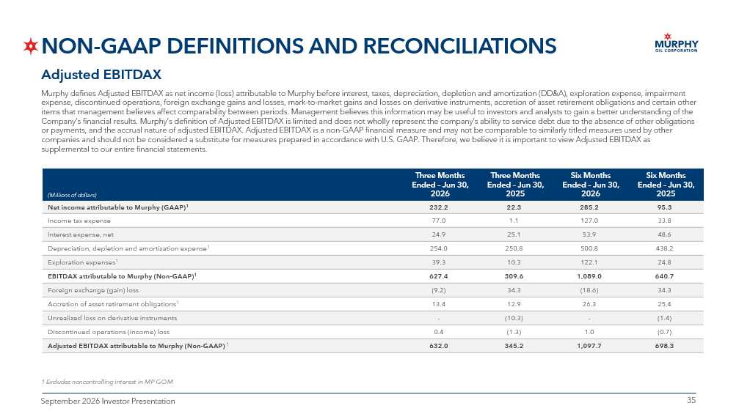
35 35 September 2026 Investor Presentation NON - GAAP DEFINITIONS AND RECONCILIATIONS Adjusted EBITDAX Murphy defines Adjusted EBITDAX as net income (loss) attributable to Murphy before interest, taxes, depreciation, depletion a nd amortization (DD&A), exploration expense, impairment expense, discontinued operations, foreign exchange gains and losses, mark - to - market gains and losses on derivative instruments, accretion of asset retirement obligations and certain other items that management believes affect comparability between periods. Management believes this information may be useful to in ves tors and analysts to gain a better understanding of the Company’s financial results. Murphy’s definition of Adjusted EBITDAX is limited and does not wholly represent the company’s a bil ity to service debt due to the absence of other obligations or payments, and the accrual nature of adjusted EBITDAX. Adjusted EBITDAX is a non - GAAP financial measure and may not be compara ble to similarly titled measures used by other companies and should not be considered a substitute for measures prepared in accordance with U.S. GAAP. Therefore, we believe it is important to view Adjusted EBITDAX as supplemental to our entire financial statements. 1 Excludes noncontrolling interest in MP GOM Six Months Ended – Jun 30, 2025 Six Months Ended – Jun 30, 2026 Three Months Ended – Jun 30, 2025 Three Months Ended – Jun 30, 2026 (Millions of dollars) 95.3 285.2 22.3 232.2 Net income attributable to Murphy (GAAP) 1 33.8 127.0 1.1 77.0 Income tax expense 48.6 53.9 25.1 24.9 Interest expense, net 438.2 500.8 250.8 254.0 Depreciation, depletion and amortization expense 1 24.8 122.1 10.3 39.3 Exploration expenses 1 640.7 1,089.0 309.6 627.4 EBITDAX attributable to Murphy (Non - GAAP) 1 34.3 (18.6) 34.3 (9.2) Foreign exchange (gain) loss 25.4 26.3 12.9 13.4 Accretion of asset retirement obligations 1 (1.4) - (10.3) - Unrealized loss on derivative instruments (0.7) 1.0 (1.3) 0.4 Discontinued operations (income) loss 698.3 1,097.7 345.2 632.0 Adjusted EBITDAX attributable to Murphy (Non - GAAP) 1

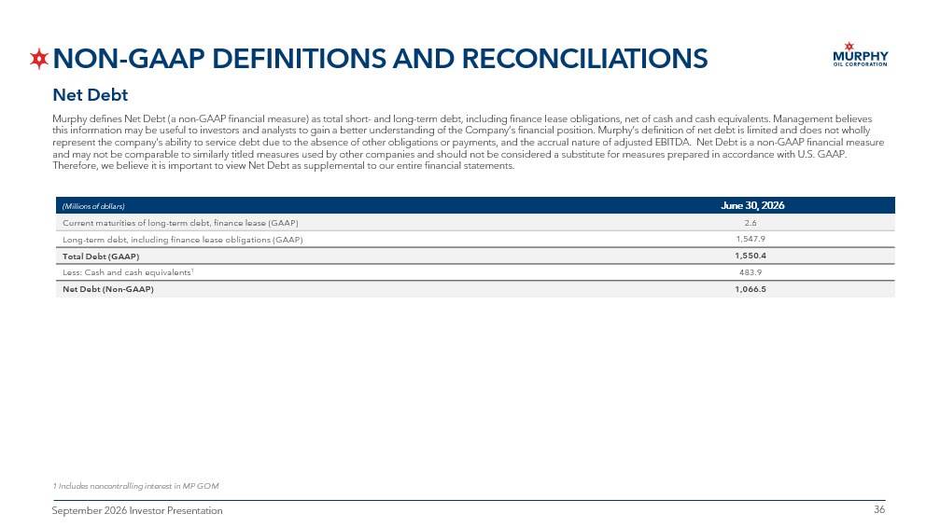
36 36 September 2026 Investor Presentation NON - GAAP DEFINITIONS AND RECONCILIATIONS Net Debt Murphy defines Net Debt (a non - GAAP financial measure) as total short - and long - term debt, including finance lease obligations, net of cash and cash equivalents. Management believes this information may be useful to investors and analysts to gain a better understanding of the Company’s financial position. Mur phy’s definition of net debt is limited and does not wholly represent the company’s ability to service debt due to the absence of other obligations or payments, and the accrual nature o f a djusted EBITDA. Net Debt is a non - GAAP financial measure and may not be comparable to similarly titled measures used by other companies and should not be considered a substitute for mea sures prepared in accordance with U.S. GAAP. Therefore, we believe it is important to view Net Debt as supplemental to our entire financial statements. June 30, 2026 (Millions of dollars) 2.6 Current maturities of long - term debt, finance lease (GAAP) 1,547.9 Long - term debt, including finance lease obligations (GAAP) 1,550.4 Total Debt (GAAP) 483.9 Less: Cash and cash equivalents 1 1,066.5 Net Debt (Non - GAAP) 1 Includes noncontrolling interest in MP GOM

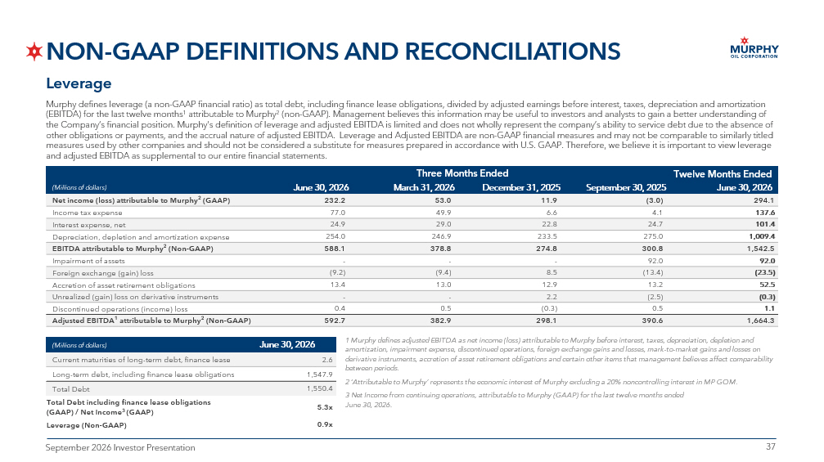
37 37 September 2026 Investor Presentation NON - GAAP DEFINITIONS AND RECONCILIATIONS Leverage Murphy defines leverage (a non - GAAP financial ratio) as total debt, including finance lease obligations, divided by adjusted ear nings before interest, taxes, depreciation and amortization (EBITDA) for the last twelve months 1 attributable to Murphy 2 (non - GAAP). Management believes this information may be useful to investors and analysts to gain a better understanding of the Company’s financial position. Murphy’s definition of leverage and adjusted EBITDA is limited and does not wholly represen t t he company’s ability to service debt due to the absence of other obligations or payments, and the accrual nature of adjusted EBITDA. Leverage and Adjusted EBITDA are non - GAAP financial m easures and may not be comparable to similarly titled measures used by other companies and should not be considered a substitute for measures prepared in accordance with U.S. GAAP . T herefore, we believe it is important to view leverage and adjusted EBITDA as supplemental to our entire financial statements. Twelve Months Ended Three Months Ended June 30, 2026 September 30, 2025 December 31, 2025 March 31, 2026 June 30, 2026 (Millions of dollars) 294.1 (3.0) 11.9 53.0 232.2 Net income (loss) attributable to Murphy 2 (GAAP) 137.6 4.1 6.6 49.9 77.0 Income tax expense 101.4 24.7 22.8 29.0 24.9 Interest expense, net 1,009.4 275.0 233.5 246.9 254.0 Depreciation, depletion and amortization expense 1,542.5 300.8 274.8 378.8 588.1 EBITDA attributable to Murphy 2 (Non - GAAP) 92.0 92.0 - - - Impairment of assets (23.5) (13.4) 8.5 (9.4) (9.2) Foreign exchange (gain) loss 52.5 13.2 12.9 13.0 13.4 Accretion of asset retirement obligations (0.3) (2.5) 2.2 - - Unrealized (gain) loss on derivative instruments 1.1 0.5 (0.3) 0.5 0.4 Discontinued operations (income) loss 1,664.3 390.6 298.1 382.9 592.7 Adjusted EBITDA 1 attributable to Murphy 2 (Non - GAAP) 1 Murphy defines adjusted EBITDA as net income (loss) attributable to Murphy before interest, taxes, depreciation, depletion and amortization, impairment expense, discontinued operations, foreign exchange gains and losses, mark - to - market gains and losses on derivative instruments, accretion of asset retirement obligations and certain other items that management believes affect com par ability between periods. 2 ‘Attributable to Murphy’ represents the economic interest of Murphy excluding a 20% noncontrolling interest in MP GOM. 3 Net Income from continuing operations, attributable to Murphy (GAAP) for the last twelve months ended June 30, 2026. June 30, 2026 (Millions of dollars) 2.6 Current maturities of long - term debt, finance lease 1,547.9 Long - term debt, including finance lease obligations 1,550.4 Total Debt 5.3x Total Deb t including finance lease obligations (GAAP) / Net Income 3 (GAAP) 0.9x Leverage (Non - GAAP)

38 38 September 2026 Investor Presentation Barclays 40th Annual Energy - Power Conference 2026 ERIC M. HAMBLY PRESIDENT AND CHIEF EXECUTIVE OFFICER SEPTEMBER 9, 2026

